TESL 560 Final Project: Inglés Con Confianza
Bethany Anderson
Azusa Pacific University

Table of Contents
Chapter 1: Context……………………………………………………………………………….. 3
Chapter 2: Beliefs ……………………………………………………………………………….. 7
Chapter 3: Needs Analysis ……………………………………………………………………... 12
Chapter 4: Learning Outcomes ………………………………………………………………… 16
Chapter 5: Syllabus …………………………………………………………………………..… 19
Chapter 6: Materials ………………………………………………………………………….… 22
Chapter 7: Assessment …………………………………………………………………………. 26
References ……………………………………………………………………………………… 30
Appendix A: Registration Form ………………………………………………………………... 34
Appendix B: How Do You Feel About Speaking English? ………………………….………… 36
Appendix C: My English Goals ………………………………………………………………... 39
Appendix D: Syllabus ………………………………………………………………………….. 41
Appendix E-H: Textbook Samples ……………………………………………………….……. 45
Appendix I: Vocabulary Quiz ………………………………………………………………….. 50
Appendix J-L: Video Assignment Instructions ………………………………………………… 51
Appendix M: Exit Interview Questions ………………………………………………………... 54

Chapter 1: Context
West Liberty, Iowa is home to just under 4,000 residents and in many ways is exactly what you would expect from a small Midwestern town: quiet, tree-lined neighborhoods and a downtown area with a couple dozen local businesses including Fred’s Feed & Supply where a sign behind the counter boasts, “If we don’t have it, you don’t need it.” But there is also something unexpected about West Liberty: in 2011, it became the first town in Iowa to have a Hispanic majority population (Schaper, 2011). Many of these are Latin American immigrants who were drawn to the availability of jobs at the turkey processing plant, West Liberty Foods, which employs approximately 600 workers locally. Spanish speakers comprise 44% of the total population of West Liberty and 85% of non-citizen residents of West Liberty were born in Latin America (World Population Review, 2019). Foreign born residents come from Mexico, El Salvador, and more recently, Puerto Rico. You can buy fresh churros and conchas at Acapulco Bakery, tamales and chimichangas at the grocery store deli, and pupusas every other Friday at Molina Brothers auto repair shop.
I have lived and taught English to adults in West Liberty for the past eight years and as a result of my teaching experiences, I realized that there is a significant gap in ESL classes that meet the needs of working adults at a beginning English level. Many of these individuals work long hours at manufacturing jobs and although many have a desire to learn English, between work and caring for their families they have little extra time or energy to attend classes. I have decided to develop my own courses that will meet these needs and offer them as part of a private English program, Anderson Language Center.
This program will serve Spanish-speaking students ranging in age from 25 to 55, primarily women. Students come from a variety of educational backgrounds: many have only completed middle school in their home countries, others completed high school, while a small minority are college educated. Most students have previously attended ESL classes in the U.S., often sporadically or for a short time. The majority of students are employed in manufacturing jobs and work up to 10 hours per day; most have school-age children. Students have lived in the U.S. for over a year, some up to 20 years. Students’ English proficiency levels range from Novice Low to Intermediate Low according to ACTFL guidelines. Students are interested in developing listening and speaking skills to help with daily communication needs in contexts such as work, the doctor’s office, or their children’s school.
Classes will follow an online format with an optional monthly face-to-face component in order to accommodate a variety of schedules. The face-to-face sessions will meet on Saturday mornings in a local office space (my husband’s business) which is unoccupied on weekends. In addition to the availability of meeting space, Saturdays tend to be a day when fewer people work, and childcare is more readily available. Face-to-face meetings will follow a tutoring-style format and will allow students who come to ask questions and receive help with areas of difficulty without causing students who are unable to attend to miss out on crucial content.
Online classes will be comprised of pre-recorded video lessons, accessed through Google Classroom, along with accompanying homework, assignments, quizzes, and asynchronous student video discussions on VoiceThread. Because of the introduction of technology that will likely be unfamiliar to most students, a face-to-face orientation session will be offered between registration and the start of classes to teach students how to upload and use the necessary tech tools on their phone or laptop. Students will be required to complete coursework during the week it is assigned, but they will have flexibility within those parameters and can study on the days and times that best fit their schedule. Although students could participate from anywhere in the world, the focus will be on attracting students within this local community, since this provides an opportunity to establish trust and rapport between students and teacher face-to-face.
Each class will be 12 weeks in length, with three terms offered per year. Placement in courses will be based on the BEST Plus oral interview assessment (Center for Applied Linguistics, 2019). At this time, only students at a high beginning listening/speaking level or below (according to Best Plus score) will be accepted to the program, although classes for intermediate levels may be added at a later date.
The first course offered will be Inglés Con Confianza (English With Confidence) class which will be a prerequisite to all subsequent classes. Inglés Con Confianza will provide substantial L1 (Spanish) support to give students a solid foundation in basic English listening/speaking skills and set them up for success in future classes. Courses will consist of four 15-minute video lessons per week, with homework assignments, video discussions and speaking tasks equaling approximately 3 hours of student work per week, bringing the total instruction time to 48 hours for each 12-week class. The Word by Word Picture Dictionary and accompanying workbook (Molinsky & Bliss, 2007) will be a required text for the course, and additional materials will be created and gathered as needed to fill instructional gaps. The online platform used will function with only a mobile smartphone (Both Google Classroom and VoiceThread have mobile apps) as many students do not have a home computer.
There will be a cost for students to participate in the course, but an effort will be made to set the price within an affordable range for the average student while still requiring a significant financial investment from the student. This will increase learners’ motivation and the likelihood that they will follow through and finish the course. In the future, if cost is found to be a significant barrier, students’ employers may be approached to request that they consider covering a portion of the employee’s class cost. Additionally, one 50% scholarship will be awarded per course to allow one student to attend who otherwise would not have been able to afford the class.

Chapter 2: Beliefs
A teacher’s core beliefs have a significant influence on what and how she teaches. Graves (2000) has emphasized the importance of articulating beliefs as part of the process of course design because “the more aware you are of your beliefs the easier it is to make decisions, or at least to know why you are making the decisions” (p. 26). Teacher beliefs relevant to language course design fall under the categories of language, learning and learners, teaching, and social context (Graves, 2000). My own beliefs relative to these four areas of second language pedagogy—as well as the ways my Christian faith influences these beliefs—are articulated as follows.
Language
I believe that the primary purpose of language is to bring people together through the connection of communication. God communicates with us through his written Word, the Bible, and we communicate with God and each other using language. The tower of Babel (Genesis 11) created a breakdown in communication and therefore a division and separation of people who spoke different languages. When God sent the Holy Spirit at Pentecost (Acts 2), the manifestation of the Spirit’s presence was the supernatural ability to speak in other languages—a miracle that illustrated God’s heart for people of all races, ethnicities, and languages to be restored to unity and fellowship. Smith (2009) described the connection between these two biblical events: “the Babel project. . . finds its redemptive counterpart as people hear one another anew, each in their own language” (Chapter 7, “The lover of mankind,” para. 3). When we learn a new language, we begin to repair the breakdown in communication that occurred at the tower of Babel, and we mirror God’s heart for the restoration of unity and fellowship between all people. Learning a language builds a bridge between people and allows for connection and understanding where there once was division.
A focus on effective interpersonal communication as a measure of language proficiency can be described using the idea of communicative competence which has been conceptualized as the combination of grammatical/linguistic, strategic, sociocultural/sociolinguistic, functional/actional, and discourse competencies (Canale & Swain, 1980, Canale, 1983, Celce-Murcia, Dörnyei, & Thurrell, 1995, Bachman & Palmer, 1996). Brown (2007) describes this view of communicative competence as follows:
Communicative goals are best achieved by giving due attention to language use and not just usage, to fluency and not just accuracy, to authentic language and contexts, and to students’ eventual need to apply classroom learning to previously unrehearsed contexts in the real world. (p. 79)
In other words, language proficiency involves the learner’s ability to communicate, however imperfectly, in a way that allows for understanding between speaker (or writer) and listener (or reader). Language is a tool for connection between people and is innately relational. Through the avenue of shared language, respect can be cultivated, new friendships can grow, and a new door can be opened to mutual understanding.
Learning and Learners
I believe that learning encompasses the whole person, and that the affective domain is a crucial component of successful language learning. Arnold and Brown (1999) have defined affect as “aspects of emotion, feeling, mood, or attitude which condition behavior” (p. 1). Before students can achieve proficiency in a language, they need to develop the communicative confidence to be willing to take risks (Clément, Baker, & MacIntire, 2003). Many students struggle with anxiety related to learning a second language, and this can cripple their progress. Rubio-Alcalá (2017) has stated that “probably no other affective factors exert so much influence in the FL classroom as self-esteem and anxiety do” (p. 198). When I talk to people who have been living in the U.S. for years and have not been able to learn English, it often becomes clear that there are significant affective barriers hindering their success. Some of these factors include low self-confidence, an underestimation of their abilities, (“I’ve tried, the words just don’t stick in my brain”), or fear of failure or ridicule (“I’m afraid I won’t pronounce it right and people will laugh at me”). These learners need targeted strategies to help them manage their fears and anxiety, lower inhibition, and increase self-esteem and willingness to take risks.
We see an example of affective factors inhibiting willingness to communicate in Exodus when God called Moses to lead his people out of Egypt. Moses voiced his fears about what he considered his inferior speaking skills: “Oh my Lord, I am not eloquent, either in the past or since you have spoken to your servant, but I am slow of speech and of tongue.” The Lord then replied with this reassurance: “Who has made man’s mouth? Who makes him mute, or deaf, or seeing, or blind? Is it not I, the Lord? Now therefore go, and I will be with your mouth and teach you what you shall speak” (Exodus 4:10-12, ESV). Like Moses, students need to be reassured that they can be successful and that someone is there to help them navigate their fears and insecurities.
Teaching
I believe that the teacher should strive to create a warm and nurturing environment to help foster language growth. Especially at beginning levels, learners need a gentle approach, much as a plant needs the sheltered environment of a greenhouse as it is beginning to grow. One way to provide a sheltered approach for beginners is by providing L1 support when practical and feasible. Brown (2007) has also offered suggestions for building rapport and creating a positive classroom environment by “showing interest in each student as a person” and “valuing and respecting what students think and say” (p. 253). Snow (2001) emphasized the benefits of being a good listener: “when the teacher listens to students’ ideas, demonstrates interest, and encourages other students to pay attention as well, the implied message is that students’ ideas—and students themselves—are of value” (p. 88). All these approaches build trust with students and have the power to break down barriers to effective learning.
I also believe that language teaching should be focused on equipping students for real-life situations. Task-based language teaching is one approach that can help achieve this goal because “tasks ultimately point learners beyond the forms of language alone to real-world contexts” (Brown, 2007, p. 52). Classroom instruction should set learners up for success in real world contexts, “equipping our students with tools for generating unrehearsed language performance ‘out there’ when they leave the womb of our classrooms” (Brown, 2007, p. 45). When I teach students something that they can immediately put to use when they walk out of the classroom and go to the grocery store or their child’s school, they feel that they are learning something that is valuable and relevant to their lives.
Social Context
I believe that using learners’ L1 within the context of the L2 classroom is an effective way to both enhance second language learning and to value learners’ culture and language identity. Utilizing other languages as a part of second language instruction has recently begun to be recognized as a valuable tool for facilitating learning as part of a plurilingual approach (Cook, 2001, Cummins, 2007, Carson & Kashihara, 2012). López and González-Davies (2016) have found that both Pedagogically Based Code-Switching (PBCS) and translation (Translation for Other Learning Contexts, or TOLC) “hold a positive place in language learning and intercultural development when the aim is to train plurilingual speakers with plurilingual skills, rather than aiming for the usually unattainable task of training for native-speaker-like language use” (p. 76). I have observed this positive effect in classes where all the students speak Spanish. When I provide an explanation of a difficult concept in Spanish or give the Spanish translation of a word that is difficult to define, students immediately grasp the idea and I am able to avoid confusion and overwhelm. Cenoz and Gorter (2013) have advocated “softer boundaries” between languages, taking advantage of “the opportunity to accelerate the learning process by using plurilingualism as a resource and not as an obstacle” (p. 597).
As an English teacher, I want to communicate to students that I respect and value their home language, nationality, and cultural heritage. One way I can do this is by speaking to them in their first language, which I have spent years working hard to learn. Snow (2009) has emphasized the importance of English teachers being language learners themselves, claiming, “it does little good to tell speakers of other languages that their languages are important if they see no concrete evidence that such assurances are based on a genuine appreciation of the value of their languages” (p. 182). When I speak to students in the language they feel most comfortable in—and the one I feel least comfortable in—I am following Christ’s example of humble servanthood. “For who is the greater, one who reclines at table or one who serves? Is it not the one who reclines at table? But I am among you as the one who serves” (Luke 22:27, ESV). For our profession we might paraphrase, Who is more important, the teacher or the student? Do you think it’s the teacher? It is actually the one who surrenders her advantage of power and authority to become the learner.
Chapter 3: Needs Analysis
Discussion
Needs assessment is an essential starting point for any class. Richards (2017) described needs analysis as “collecting information on the kinds of activities and purposes the learner will use English for” (p. 79). Needs assessments can also guide the direction of the course on an ongoing basis. Graves (2000) emphasized the continuing cycle of needs assessment in her definition: “a systematic and ongoing process of gathering information about students’ needs and preferences, interpreting the information, and then making course decisions based on the interpretation in order to meet the needs” (p. 98). The type of information gathered should depend on the context and focus of the course, but data can include language ability, learning preferences, attitudes, goals and expectations, target contexts, and communicative skills and language modalities needed (Graves, 2000).
Needs assessment should be an important component of curriculum development for several reason: 1) it allows learners to participate in the direction of their instruction as part of a learner-centered approach (Nunan, 1988), 2) it highlights any discrepancies between the learner’s felt needs and the teacher’s or institution’s perceived needs (Berwick, 1989), 3) it allows the teacher to address any unrealistic expectations at the beginning of the course (Graves, 2000), and 4) it provides the opportunity for the course to become more relevant and engaging for learners as the content is tailored to their needs. Graves (2000) underlined the importance of treating student responses as valuable by acting on them (either in the present course or future courses) or explicitly communicating the rationale for choosing not to act on them to avoid students feeling like their input is being ignored.
Since this is a privately offered course, the primary stakeholders are the students themselves. Based on information gathered through previous needs assessments and interviews in similar contexts, I have predicted students’ main interests and concerns as follows:
- Students need English to navigate work and daily life situations successfully and independently.
- Listening and speaking skills are the most important language modalities for most target contexts.
- Limited progress despite living in the US for several years and taking other ESL classes has resulted in low self-efficacy, self-concept, or self-esteem (Rubio-Alcalá, 2017) for some students.
- Negative experiences have led to feelings of fear, nervousness, or frustration when attempting to speak English.
Information collected as part of the following needs assessment plan will serve to confirm or challenge this understanding of students’ primary needs and motivations and will shape the content of the present class as well as future courses offered.
Student Data to be Collected
Table 1 details the information that will be collected from students, and the timeframe to be followed.

Table 1
Needs Assessment Plan
Timeframe | Data to Collect | Method of Collection | Rationale
Pre-Course | - Length of time living in US  - Previous English study  - Motivation for attending class  - Areas of difficulty with English  - Negative experiences speaking English  - Expectations for the class | Questionnaire  (Registration Form: Appendix A) | Helps the teacher to understand student motivation and prepare to address affective barriers to learning. If expectations are unrealistic, the teacher can help to adjust expectations. Information about previous study will provide additional insight into instructional expectations.
Initial (first week) | Affective responses associated with speaking English | Questionnaire  (How Do You Feel Speaking English?: Appendix B) | Helps students articulate their feelings and attitudes surrounding language learning.
Initial (first week) | Goals/Target Needs | Questionnaire  (My English Goals:  Appendix C) | Helps students identify important target contexts and set goals for the skills they want to focus on.
Ongoing | - Students’ perceptions about their language learning process  - Ways they are using English in daily life  - Progress they are making toward their goals | Conferences, video journal | Monitors students’ progress towards their goals, improvement in affective factors like self-efficacy and anxiety, and the degree to which learning expectations are being met.

Prior to the start of the class, students will fill out the Registration Form (Appendix A) where they will provide information about their motivation for taking the class, previous ESL classes taken, and any negative experiences and feelings related to language learning. This information will help me to have a clearer picture of my students’ backgrounds and priorities before the start of the class.
During the first week of classes, I will use a questionnaire in Spanish (Appendix B) adapted from Horwitz’ (1983) Foreign Language Classroom Anxiety Scale (in Horwitz & Young, 1991) to assess learners’ affective responses to speaking English in their daily lives. I will also use the “My English Goals” worksheet (Appendix C) to help students identify their most important target contexts and use these as a basis for setting three personal English learning goals. Graves (2000) claimed that “students need to be given support and guidance in how to set goals” (p. 108). This worksheet walks learners step-by-step through a simplified goal-setting process and will be understandable even for students with no prior experience creating personal goals. All pre-course and initial needs assessments will be provided in Spanish in order to collect the highest quality data possible. All forms will be made available to students using Google Forms.
On a monthly basis, I will assign an audio/video language learning diary (Graves, 2000) entry for students to report on the ways they are using English in their daily lives and their feelings about speaking English. This will be submitted using VoiceThread but will be private between the individual student and myself. I will respond to each diary submission to provide encouragement and helpful suggestions. At the midpoint of the course, I will meet with each student individually (face to face or via video chat) to check in with them about their learning experience and elicit concerns or frustrations in addition to specific aspects of the class they feel are working well.

Chapter 4: Learning Outcomes
Learning outcomes provide a description of what the student will be able to do after successfully completing the course. Richards (2017) described learning outcomes as a statement of “the kinds of performance or language practices that the learner can demonstrate at the end of a unit of learning” (p. 147). Outcomes should follow the SMART acronym (Doran, 1981) of specific, measurable, achievable, realistic, and timebound, and should utilize Bloom’s taxonomy (Bloom, 1956) describing cognitive processes ranging from knowing to evaluating. Learning outcomes should employ specific verbs such as identify and recognize vs. vague words like know or understand. Outcomes are directly linked to assessment in that they “provide a standard for assessment or testing” (Richards, 2017, p. 147). A carefully articulated learning outcome will make it easy to create an assessment that measures whether the outcome has, in fact, been achieved. Without clear outcomes, a course lacks purpose and direction, and it leaves teacher and students with the question of what they actually accomplished in the course.
Table 2
Course Outcomes
Outcome  “By the end of this course, students will be able to. . .” | Rationale
Use 75 vocabulary words and phrases related to daily life interactions in appropriate oral contexts. | Building vocabulary is key to increasing proficiency, especially at beginning levels. Common, versatile phrases will help students communicate in a variety of contexts.
Use basic vocabulary and grammar structures to complete 10 simple real-life tasks. | Assigning communicative tasks to be completed outside the classroom within the community will increase motivation for learning vocabulary and forms and will help students feel more confident when they encounter these same situations in the future.
Evaluate the usefulness of two affective strategies used to minimize anxiety when speaking English. | Students will reflect on strategies they learned during the course and will evaluate which three were most effective in increasing their confidence and willingness to take risks in English.
Learning Outcome 1: Students will be able to identify 75 vocabulary words and phrases related to daily life interactions.
Throughout the course, students will learn vocabulary words and phrases (or language “chunks”) that will allow them to successfully carry out the real-life tasks assigned (see Learning Outcome 2). Selivan (2018) has claimed that knowledge of chunks is key to developing fluency because “it is much quicker to process a few larger units (chunks) than a lot of smaller ones (words)” (p. 4). Both language chunks (e.g., Excuse me, I’m looking for the ____) and vocabulary items (e.g., cereal) are selected for maximum versatility and usefulness in common contexts students are likely to encounter, such as the grocery store, restaurant, post office, library, and bank. For students at a beginning level, it is essential to build a basic lexis that will enable learners to carry out important communication tasks such as requesting help, asking for clarification, and providing basic information. The target number of items and phrases to be learned is realistic for the 12-week course (approximately 6 words/phrases per week) and allows time for students to focus on learning a few things well for maximum retention.
Vocabulary acquisition will be assessed using a weekly vocabulary quiz and through a “teaching video” which students will create each week to “teach” three vocabulary items they have selected from the vocabulary list by explaining the meaning of the word/phrase, along with an example of a sentence and context in which it would be used. Quizzes will focus on the phrases learned for the week’s task and will follow a multiple choice or fill-in-the blank format and will be created using Google Forms to provide the learner with immediate feedback.

Learning Outcome 2: Students will be able to use basic vocabulary and grammatical structures to complete 10 simple real-life tasks.
Each week, students will practice vocabulary and forms tailored to a specific task. At the end of the week, learners will carry out the task assigned in the context indicated. One week, the task might be to ask a store employee for help finding a food item at the grocery store and another week it might be to mail a package at the post office. Students will carry out the task at a time and place of their choice and will subsequently submit a video report on the week’s task. This outcome will be measured using the video reports which will provide information on what the student said, how the person they were speaking to responded, and how the student felt about the interaction.
Learning Outcome 3: Students will be able to evaluate the usefulness of two affective strategies used to minimize anxiety when speaking English.
Each week, students will learn a new affective strategy which they will be encouraged to use while carrying out the real-life task of the week. Strategies are designed to minimize stress and anxiety, while boosting confidence and increasing willingness to take risks. Strategies range from recognizing that “mistakes help me learn” to taking a deep breath before approaching someone with a question in English.
At the end of class, students will be asked to reflect on strategies they learned during the course and will evaluate which two were most effective in increasing their confidence and willingness to take risks in English. They will then create a video in VoiceThread discussing these two strategies, and how they used them (these videos can be done in Spanish).

Chapter 5: Syllabus
Discussion
A syllabus is a framework for arranging course content in a logical, effective way within the time allotted to successfully achieve the learning outcomes. Graves (2000) described a syllabus as “the product of organizing and sequencing a course” (p. 125). The primary elements involved in the process of syllabus design are the organizing principles, units of instruction, sequencing, and content (Graves, 2000). Without a syllabus to arrange and sequence content, the course would lack the organization needed to create a cohesive whole, rather than a series of random, unrelated lessons.
When designing the syllabus, it is important that the teacher consider learners’ perceived and felt needs and proficiency level, the desired course outcomes, the teacher’s core beliefs about teaching and learning, and the constraints of context, institution, and time. Richards (2017) stated that “decisions about syllabus and course content reflect the planners’ assumptions about the nature of language, language use, and language learning, about what the most essential elements or units of language are, and how these can be organized” (p. 164). The syllabus should clearly show what the teacher feels is most important for students to learn, as well as by what means and in what order they will best learn it.
Organizing Principles
The syllabus included (Appendix D) is designed as an organizing tool for the instructor and will not be provided to students in the form shown. A simplified version of important information will be provided to students in Spanish in video format with thorough explanation from the instructor. Course information will be divided into several videos for students to watch during the first week to avoid overwhelming them with too much information, and individual assignment information will be provided at the time they are assigned.
The course syllabus follows a task-based organization. Task-based instruction is concerned with the relevance of course content to learners’ daily lives and focuses on real-world tasks as the primary vehicle for language instruction (Richards, 2017). Tasks chosen should “resemble the kinds of tasks learners will have to accomplish or carry out in the real world” (Richards, 2017, p. 173). In this course, each task is chosen based on its accessibility to all students (regardless of where they live or work) and appropriate level of difficulty for beginners. A task-based syllabus framework is a good fit for this course because one of the main goals is to help students believe that they are capable of successfully interacting in English in their daily lives. Receiving instruction targeting specific, real-life tasks outside the classroom which learners will then actually carry out in the real world has the potential to jumpstart both their level of confidence and their English speaking skills.
Course Content and Sequence
In each of the twelve weeks of the course, lessons and activities will equip students to successfully carry out a real-world task as an assignment at the end of the week. Students will learn vocabulary words and language chunks which will be used to carry out that week’s task. Rather than following a traditional grammatical progression of instruction, tasks are organized in order of simplest to most complex in terms of length and difficulty of the interaction required. This approach focuses on meaning over form (Richards, 2017) and walks students step-by-step through a progression of increasingly challenging tasks ranging from asking for help at a store to scheduling a medical appointment. In addition, there is a parallel affective “micro strand” (Richards, 2017) to the syllabus which introduces concepts and strategies each week to improve learners’ confidence speaking English and is independent from the task-related instruction.
The Word by Word Picture Dictionary (English/Spanish edition) and accompanying workbook (Molinsky & Bliss, 2007) is used for vocabulary instruction and as a resource for self-study. Beyond the vocabulary chosen by the instructor, students are asked to select six vocabulary items of their choice to study each week from the assigned section of the book (e.g., post office) based on what is most relevant to them personally. This allows students to learn what they need to know and what is most interesting to them. Accountability will be provided for learning these vocabulary items by means of a “teaching video” assignment (see Appendix J). Grammar instruction will be minimal to maintain an emphasis on meaning, although structures (e.g., I’d like to mail this package, Week 9) will be explained to the extent necessary for students to understand their component parts (I’d means I would), the order in which the words are arranged, and some variations that can be used for different purposes (I would like to take a vacation this summer).

Chapter 6: Materials
Course materials need to be evaluated based on a variety of factors including the length of the course, instructor’s teaching style, and learners’ needs, interests, and proficiency level (Richards, 2017). A good textbook can save the teacher time and effort and provide a structure for organizing the course without ‘reinventing the wheel.’ However, there is no such thing as a perfect text, and adaptation will always be a necessary component of teaching from a textbook. Richards (2017) stated, “through the process of adaptation, the teacher personalizes the text, making it a better teaching resource, and individualizes it for a particular group of learners” (p. 251). A teacher’s beliefs should form the basis for deciding what is and is not important for students to learn, and by extension, what to add and what to leave out from the textbook (Graves, 2000). With a thoughtful selection of textbook content and supplemental resources, teachers can curate the materials that best fit students’ learning needs and interests as well as the course learning outcomes.
The primary texts selected for this course are the Word by Word Picture Dictionary Spanish/English edition (Molinsky & Bliss, 2007) and the accompanying Word by Word Beginning Vocabulary Workbook (Appendices E-H). Since this course is centered around real-life tasks, a traditional leveled ESL textbook will not fit the needs of the class because it would require too much adjustment and reorganization. As Graves has pointed out, it is not worthwhile to use a textbook “if you have to do so much work to adapt [it] that you might as well develop your own materials” (p. 175). Choosing a picture dictionary rather than a standard textbook allows for more flexibility in the tasks selected and the order of instruction, while still providing a useful learning resource for students. Additionally, a picture dictionary lends itself to independent study better than many traditional textbooks (which are often designed to facilitate in-class activities), making it ideal for an online class format where students will be using the textbook on their own at home.
Table 3
Textbooks Used
 | Title: | Publisher:
Primary Texts | Word by Word Picture Dictionary (Spanish/English)  Word by Word Beginning Vocabulary Workbook | Pearson
Additional Texts  (as needed) | Focus on Grammar  -or-  Grammar and Beyond Essentials | Pearson  Cambridge

Strengths:
One of the primary strengths of the Word by Word Picture Dictionary is that I have used it extensively in similar teaching contexts and it has been well-received by students. I have mainly used it as a supplemental resource for learning vocabulary at home, and many students opted to buy it even when it was not required. From feedback students have given me in the past, I know that they enjoy using this book as a study aid, and that it effectively meets their felt needs. One factor that may contribute to its popularity among students is that the book is visually appealing, and the illustrations are detailed and engaging. Students also appreciate the L1 support provided by the Spanish translations of vocabulary words (bilingual versions are also available in several other languages).
Another strength of the Word by Word Picture Dictionary is that it includes relevant vocabulary needed for all the tasks in the course. The picture dictionary is organized by topic (see Appendix) and includes sections focusing on food and grocery store, restaurants, post office, library, and a variety of other contexts relevant to students’ daily lives. The large number of vocabulary items in each unit allow for flexibility in selecting the most useful words for each task, and it provides an easy way to involve students by allowing them to select the vocabulary that is most relevant to them. It would also allow for adaptation of the course tasks based on students’ interests and needs, as there are many additional daily-life topics included. Additionally, at under $25 for the dictionary/workbook bundle (at classroom pack pricing from the publisher) the books are affordable, making it a realistic option for students paying out-of-pocket.
Weaknesses:
One of the main weaknesses of this book is that it is not a comprehensive textbook and instructional content is limited. Instead of using the textbook as a framework for structuring lessons, the teacher is required to either or use the picture dictionary in conjunction with another textbook (as the publisher recommends) or to plan lessons from scratch (as I will do). In the context of a course structured around specific tasks, the picture dictionary plays an effective supporting role, but there is little to no planning time saved by using this book, as might be the case with other texts.
Another weakness of the primary text is that it has a word-level focus rather than using vocabulary at the sentence or conversation level. Although there are some simple dialogues provided at the bottom of each page (see sample lesson, Appendix E) which give ideas for using the vocabulary in a conversation, it is essentially up to the teacher to fill in the gaps and teach students how to use the vocabulary in authentic contexts. Additionally, no instruction is provided on grammatical structures. For this reason, I plan to supplement as needed with a grammar text such as Focus on Grammar or Grammar and Beyond Essentials to provide focused instruction on the grammatical forms required for tasks. However, from a lexical grammar standpoint, focusing on relevant vocabulary chunks can be a more meaningful approach than beginning with a focus on grammar forms, and Selivan (2018) has advocated ‘using lexical items as a springboard for grammar exploration’ (p. 85). When students begin by looking at the words and phrases they need for specific real-life situations, it may be easier for them to understand how to use the grammatical structures needed to support this vocabulary in communicative contexts.

Chapter 7: Assessment
Discussion
Assessment of student learning is one means to evaluate the effectiveness of a course. Graves (2000) has stated that “language learning assessment answers the question What have students learned with respect to ___?” (p. 208). Clear course outcomes fill in the blank at the end of that question and help define what needs to be assessed. Student learning assessment can be formative or summative, where formative assessment is conducted while the class is in progress, providing information about students’ progress, and summative assessment takes place at the end of the course and shows whether students have met learning outcomes and if the course as a whole has been effective (Graves, 2000). Both formative and summative assessment shed light on areas of the course that require adjustment. Formative assessment allows for changes to be implemented mid-course while summative assessment provides information that will help improve future courses.
Course evaluation is another way to assess the overall effectiveness of the course and can be measured based on learning outcomes, test performance, and student satisfaction, among other factors (Richards, 2017). Course evaluation seeks to answer questions about whether the course achieved what it set out to accomplish and what changes or adjustments should be made in the future. A variety of procedures can be such as interviews, student evaluations, video recordings and observations (Richards, 2017). Reflective practices may also be implemented as part of a process-focused course evaluation. These practices focus on thoughtful questioning of what the teacher has observed in the classroom (either from journal writing, watching a video of a class, or a peer observation).
Assessment Plan
Student learning for this course will be assessed in light of the three course learning outcomes. Specific assessment techniques are detailed below.
Table 4
Assessment Plan
Learning Outcome | Assessment Techniques | Schedule
Identify 75 vocabulary words and phrases related to daily life interactions. | Vocabulary quizzes (Appendix I)  “Teaching” video (Appendix J)  Vocabulary review (Appendix K) | Weekly: 7-10 words/phrases  Weekly: 3 words  End of course: 1 phrase, 5 words
Use basic vocabulary and grammar structures to complete 10 simple real-life tasks. | Video report (Appendix L) | Weekly
Evaluate the usefulness of two affective strategies used to minimize anxiety when speaking English. | Video report | End of course

Learning Outcome 1: Students will be able to identify 75 vocabulary words and phrases related to daily life interactions.
This outcome will be assessed using three methods: vocabulary quizzes, teaching videos, and a vocabulary review. Vocabulary quizzes (Appendix I) will be closed-book, 10-item, multiple choice tests created in Google Forms. Students will take one quiz each week over vocabulary learned that week. Quizzes will utilize pictures to prompt the vocabulary word or phrase, a technique recommended by Hughes for beginning level students (2003) provided it is used only for “concrete nouns that can be unambiguously drawn” (loc. 2113). A multiple-choice format will be used to avoid testing students on spelling as well as vocabulary (Hughes 2003). Students will receive immediate feedback on their responses and the teacher will have access to all quiz results. In order to encourage students to take the tests without consulting their book or notes, incorrect responses will not count against them, but students will be encouraged to add any words/phrases to their vocabulary study cards.
For the teaching videos (Appendix J), each week students will select three vocabulary words from that week’s section of the Word by Word Picture Dictionary that are relevant and new to them. They will then create a video and post to VoiceThread to teach these three words to their classmates using definition, examples, repetition, and memory devices. At the end of the course, students will create a vocabulary review video (Appendix K) over the vocabulary learned for one week’s task. Vocabulary topics will be assigned to each student by the teacher. Students will select one phrase and five words they feel are important to remember and will post a video review of this vocabulary to VoiceThread. The 75 vocabulary words and phrases students are expected to know at the end of the course represent approximately 70% of the vocabulary tested using the weekly quizzes and teaching videos.
Learning Outcome 2: Students will be able to use basic vocabulary and grammar structures to complete 10 simple real-life tasks.
Following completion of each week’s task, students will submit a video report in VoiceThread (Appendix L) to document the experience. This will show that they have completed the task and will allow them to reflect on how the interaction went and how they felt about it. O’Malley and Valdez Pierce (1996) have advocated for the use of student self-assessment for oral language “to focus learners on their performance and progress in learning” (69). This video report will act as a self-assessment to help learners focus on what they said, how the listener responded, and the success of the interaction overall. Because the other students in the class will watch and comment on these videos, this activity will also serve to provide encouragement when students see that others are having similar experiences and feelings.
Learning Outcome 3: Students will be able to evaluate the usefulness of two affective strategies used to minimize anxiety when speaking English.
At the end of the course, students will be asked to choose two of the strategies they learned that they found most helpful and will create a video to post to VoiceThread. In the video, they will reflect on how they used these strategies and how the strategies helped them to feel more confident or less anxious when speaking English (these videos can be done in Spanish).
Course Evaluation
In addition to the assessment tools described above, an exit interview (Appendix M) will be conducted with as many students as possible either in person or by phone. This will be used to elicit information about positive and negative aspects of the course in order to gain insight into the effectiveness of the approaches used and make adjustments as needed to future courses. An interview format is being used instead of a questionnaire to facilitate deeper and more detailed responses (Richards, 2017). Additionally, I will use reflective teaching practices such as journaling and watching videos of my lessons as a means of formative course evaluation while the class is in progress.

References
Arnold, J. (Ed.). (1999). Affect in language learning. Cambridge, UK: Cambridge University Press.
ACTFL Proficiency Guidelines 2012 (n.d.). Retrieved from https://www.actfl.org/publications/guidelines-and-manuals/actfl-proficiency-guidelines-2012/english/speaking
Bachman, L., & Palmer, A. (1996). Language testing in practice. New York, NY: Oxford University Press.
Berwick, R. (1989). Needs assessment in language programming: From theory to practice. In R. K. Johnson (Ed.), The second language curriculum. Cambridge, UK: Cambridge University Press, 48-62.
Bloom, B. S., Ed. (1956). Taxonomy of educational objectives: The classification of educational goals (Handbook I). New York: Longmans, Green & Co.
Brown, H. D. (2007). Teaching by principles: An interactive approach to language pedagogy. White Plains, NY: Pearson Education.
Center for Applied Linguistics (2019). Best Plus 2.0. Retrieved from http://www.cal.org/aea/bp/
Canale, M. (1983). From communicative competence to communicative language pedagogy. In J. C. Richards & R. W. Schmidt (Eds.), Language and communication (pp. 2-28). London, UK: Routledge.
Canale, M. and Swain, M. (1980). Theoretical bases of communicative approaches to second language teaching and testing. Applied Linguistics, 1, 1-47.
Carson, E., & Kashihara, H. (2012). Using the L1 in the L2 classroom: The students speak. The Language Teacher, 36(4), 41-48.
Celce-Murcia, M., Dörnyei, Z., & Thurrell, S. (1995). Communicative competence: A pedagogically motivated model with content specifications. Issues in Applied Linguistics, 6(2), 5-35.
Cenoz, J., & Gorter, D. (2013). Towards a plurilingual approach in English language teaching: Softening the boundaries between languages. TESOL Quarterly, 47(3), 591-599.
Clément, R., Baker, S. C., & MacIntire, P. D. (2003). Willingness to communicate in a second language: The effects of context, norms, and vitality. Journal of Language and Social Psychology 22(2), 190-209.
Cook, V. (2001). Using the first language in the classroom. Canadian Modern Language Review, 57(3), 402-423.
Cummins, J. (2007). Rethinking monolingual instructional strategies in multilingual classrooms. Canadian Journal of Applied Linguistics, 10(2), 221–240.
Doran, G. T. (1981). There's a S.M.A.R.T. way to write management's goals and objectives. Management Review, 70(11), 35–36.
Graves, K. (2000). Designing language courses: A guide for teachers. Boston, MA: Heinle & Heinle.
Horwitz, E. K. and Young, D. J. (1991). Language anxiety: From theory and research to classroom implications. Englewood Cliffs, NJ: Prentice-Hall, Inc. (p. 32-33).
Hughes, A. (2003). Testing for language teachers (2nd ed.). Cambridge, United Kingdom: Cambridge University Press.
Krashen, S. (1985). The Input Hypothesis: Issues and Implications, London: Longman.
López, C. C., & González-Davies, M. (2016). Switching codes in the plurilingual classroom. ELT Journal, 70(1), 67-77.
Molinsky, S. J., & Bliss, B. (2007). Word by Word Picture Dictionary, English/Spanish (2nd ed.). White Plains, NY: Pearson Education.
Nunan, D. (1988). The learner-centred curriculum. Cambridge, UK: Cambridge University Press.
O’Malley, J. M. & Valdez Pierce, L. (1996). Authentic assessment for English language learners: Practical approaches for teachers. New York, NY: Longman.
Richards, J. C. (2017). Curriculum development in language teaching (2nd ed.). Cambridge, UK: Cambridge University Press.
Rubio-Alcalá, F. D. (2017). The links between self-esteem and language anxiety and implications for the classroom. In C. Gkonou, M. Daubney, & J.-M. Dewaele (Eds.), New insights into language anxiety: Theory, research and educational implications (198-216). Bristol, UK: Multilingual Matters.
Schaper, D. (2011). A look at Iowa’s first majority Hispanic town. Retrieved from https://www.npr.org/2011/10/10/141150607/west-liberty-is-iowas-first-majority-hispanic-town
Selivan, L. (2018). Lexical grammar: Activities for teaching chunks and exploring patterns. Cambridge, UK: Cambridge University Press.
Smith, D. I. (2009). Learning from the stranger: Christian faith and cultural diversity (Kindle version). Retrieved from amazon.com
Snow, D. B. (2001). English teaching as Christian mission: An applied theology. Scottdale, PA: Herald Press.
Snow, D. B. (2009). English teachers, language learning, and the issue of power. In M. S. Wong & S. Canagarajah (Eds.), Christian and critical English language educators in dialogue: Pedagogical and ethical dilemmas (pp. 173-184). New York, NY: Routledge.
Swain, M. (1985). ‘Communicative competence: Some roles of comprehensible input and comprehensible output in its development’ in S. Gass, & C. Madden (Eds.), Input in second language acquisition (235-253). Rowley, MA: Newbury House.
United States Census Bureau (n.d.). American fact finder. Retrieved from https://factfinder.census.gov/faces/nav/jsf/pages/community_facts.xhtml?src=bkmk
World Population Review (2019). Retrieved from: (http://worldpopulationreview.com/us-cities/west-liberty-ia-population/

Appendix A
Inglés Con Confianza
Registration Form (This form is translated from the original Spanish version)

First & last name_______________________________________________________________
Preferred name (What do you want your teacher and classmates to call you?) _______________
Address______________________________________________________________________
Phone________________________________________
Email_______________________________________________________________
How did you hear about this class? (Facebook, flier, friend, etc.)__________________________
How long have you lived in the U.S.?______________________________
Have you attended any other English class before? Yes No
If you answered “yes” indicate where:_________________________________________
If you answered yes, what was your experience like? (How did you feel about the class?)
________________________________________________________________________
Why do you want to learn English? (What is the most important reason for you?) ______________________________________________________________________________
What is something you like about English?____________________________________________
What is the most difficult part for you about English?____________________________________
Have you had any negative experiences speaking English? Think about a negative experience: What happened? How did you feel? __________________________________________________________________________________________________________________________________________________________________________________________________________________________________________
When you have to speak English to someone you don’t know, how do you usually feel? (Mark all the options that apply):
- I feel nervous
- I feel embarrassed
- I’m scared
- I start to tremble
- I start to sweat
- I forget everything I already know in English
- I feel frustrated
- I feel calm
- I feel excited
- I feel happy
- Other:______________________________
Why do you think you feel this way? What are some of the most important reasons for the answers you marked above? (Mark all the options that apply):
- I think that people are going to laugh at me
- I’m afraid I’m going to make a mistake
- I think that I should know more English than I do
- I’m afraid that I won’t understand people when they answer me
- Other: ________________________________________________________________
What is the most important thing that you want to learn during this class? ______________________________________________________________________________

Appendix B
How do you feel about speaking English?
(Students will complete a Spanish version of this questionnaire in Google Forms)
Almost always Sometimes Hardly ever
I feel insecure when I speak English
I feel confident when I speak English
I start to tremble or sweat when I have to speak English
I’m afraid that people won’t understand me when I speak English
I think that most people understand me when I speak English
I think that most people speak English better than I do
I speak English as well as most of my friends/coworkers
I panic when I have to speak English without having a chance to prepare
I worry about what will happen if I can’t learn English
I feel calm and relaxed when I need to speak English
When I have to speak English, I get so nervous that I forget words I know
I’m embarrassed to speak in English
I feel like it’s okay if I make mistakes in English
Even when I’m prepared, I feel anxious in situations where I need to speak English
I try to avoid situations when I would have to speak English
I look for chances to use my English in different situations
The more I study English, the more confused I feel
I enjoy studying English and I understand the things I learn
I feel very shy speaking English
I feel comfortable speaking English
I feel that people talk too fast in English for me to understand them
I understand people when they talk to me in English
I feel more nervous in situations when I need to speak English than in situations when I can speak Spanish
I feel nervous when I have to talk, even in Spanish
I feel confused when I try to speak in English
I get nervous when I don’t understand what people say to me in English
I can stay calm even if I don’t understand what someone says
I feel overwhelmed by all I need to learn in English
I feel confident that I will learn English
I’m afraid that people will laugh at me when I make a mistake in English
I don’t worry about what people will think when I speak English

Which of these words best describe how you feel when you speak English?
(Choose 1, 2, or 3 words)

- I’m afraid
- I’m confident
- I’m embarrassed
- I feel panicked
- I feel shy
- I feel happy
- I feel frustrated
- I feel nervous
- I feel confused
- I feel excited
- I feel dumb
- I feel worried
- I feel anxious
- I feel relaxed
- I feel stressed
- I feel self-conscious
- I feel paralyzed
- I feel calm
- My mind goes blank

Appendix C
(Students will be given a Spanish version of this questionnaire to fill out)
My English Goals Name_________________________

What can you do in English? | I can do this now | I can’t do this yet
Talk to a neighbor or friend
Talk to a friend on the phone
Understand when someone I don’t know talks to me
Read a text message someone sends me
Send a text message
Understand the cashier at the store when I am checking out
Ask a question at the store if I need help finding something
Send an email or note to my child’s teacher
Talk to my child’s teacher in Parent/Teacher Conferences
Help my child with their homework
Schedule a doctor or dentist appointment on the phone
Ask and answer questions at a doctor/dentist appointment
Understand the bank teller when I go to the bank
Explain what I need to the teller at the bank
Talk to my landlord about a problem in the apartment
Understand my supervisor/coworkers at work
Talk to my supervisor/coworkers at work
Understand TV shows and movies without subtitles
Understand people talking on the radio or a podcast

Write the 3 most important goals that you checked “I can’t do this yet”:
- ________________________________________________________________________
- ________________________________________________________________________
- ________________________________________________________________________

Appendix D
Syllabus
Note: The information below will be provided to students in Spanish using a simplified format, using a narrated slide presentation video. The purpose of the syllabus shown here is for the purpose of course planning and organization.

Course Title: Inglés Con Confianza (English With Confidence): Beginning English for Daily Life
Instructor: Bethany Anderson bethany@andersonlanguage.com
Materials:
- Word by Word Picture Dictionary, English/Spanish edition
- Google classroom app (for class videos and quizzes)
- VoiceThread app (for video discussions)
- Index cards for studying vocabulary
Rationale:
This course is designed for Spanish-speaking adults living in the U.S. who are at a beginning level of English and wish to improve their listening and speaking skills in order to successfully function in daily life interactions. It teaches basic vocabulary and grammatical structures needed for simple tasks and seeks to enable participants to communicate effectively in simple conversations. It also seeks to develop the participants’ confidence speaking English by equipping them with strategies designed to minimize language-related anxiety and inhibition.

Course Outcomes:
By the end of this course, students will be able to:
- Identify 75 vocabulary words and phrases related to daily life interactions.
- Use basic vocabulary and grammatical structures to complete 10 simple real-life tasks.
- Evaluate the usefulness of two affective strategies used to minimize anxiety when speaking English.
Policies:
Students will view video lessons in Google Classroom, participate in video discussions on VoiceThread, and complete assignments on their own time. All discussions and assignments must be completed in the week it is assigned. Sunday at midnight is the final deadline each week and no work will be accepted after this time. Students should allow 4-6 hours per week to complete coursework. It is recommended that students plan to study at least 3 days per week, but 4-6 days per week is advisable for best results. Each week, students will participate in the following activities:
- Watch 4 video lessons (approximately 15 minutes each)
- Study assigned pages in Word by Word Picture Dictionary and select vocabulary to study
- Write out vocabulary items on index cards and study each day
- Participate in discussions on VoiceThread (1-2 each week)
- Complete the assigned real-life task in the place of your choice each week
- Submit a video report each week on your experience with the real-life task on VoiceThread
- Take the vocabulary quiz each week
Assignments/Grading:
Tasks (10 tasks) ------ 50% Pass: 70% +
Video discussions ---- 30% Fail: 0-69%*
Vocabulary quizzes -- 20%
*Students who fail this course will be required to repeat it before continuing to other courses.
Course Schedule:
 | Task Focus | Language Focus | Affective Focus
Week 1 | Asking for clarification | Could you repeat/spell that, More slowly, etc. | The beginning is hard!
Week 2 | “Small Talk” with neighbors/acquaintances | Talking about weather | Small steps
Week 3 | Asking for help at the grocery store | Food vocabulary, I’m looking for___ | Mistakes are good!
Week 4 | Ordering at the deli counter | Meat and weight vocabulary, I’d like __ | What if people laugh at me?
Week 5 | Checking out at the store | Small talk review, numbers, saying goodbye | What if I don’t understand?
Week 6 | Ordering at a fast food restaurant | Fast food vocabulary, I’ll have __ | Negative experiences
Week 7 | Ordering at a sit-down restaurant | Menu vocabulary, order of service | Feeling embarrassed
Week 8 | Mailing a package at the post office | Post office vocabulary, I’d like to __ | A “can-do” attitude
Week 9 | Finding a book at the library | Library sections/media vocabulary | Taking risks
Week 10 | Scheduling a medical appointment | Providing personal information | How to relax when you feel nervous
Week 11 | Student choice | Vocabulary for task of choice (Word by Word) | Keeping a sense of humor
Week 12 | Review | Review | Don’t give up!

Bibliography:
Google Classroom app (n.d.). Retrieved from google.classroom.com
Molinsky, S. J., & Bliss, B. (2007). Word by word picture dictionary, English/Spanish (2nd ed.).White Plains, NY: Pearson Education.
VoiceThread app (2019). Retrieved from voicethread.com

Appendix E
Word by Word Picture Dictionary sample lesson
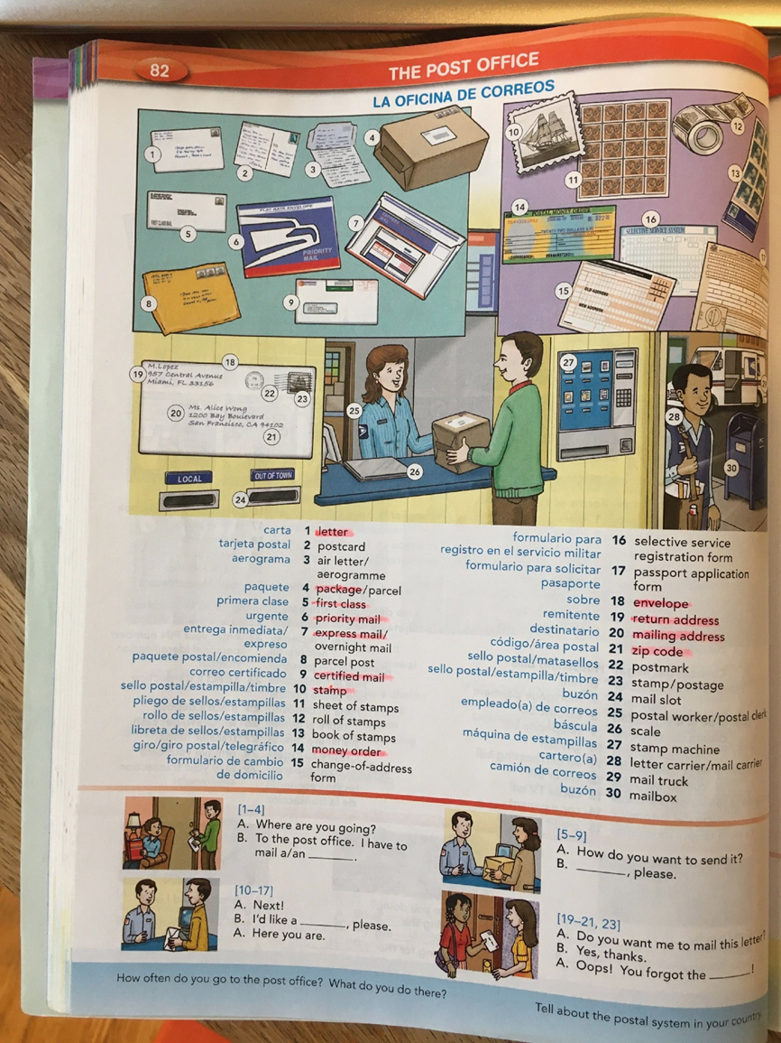
Appendix F
Word by Word Picture Dictionary Beginning Vocabulary Workbook sample page
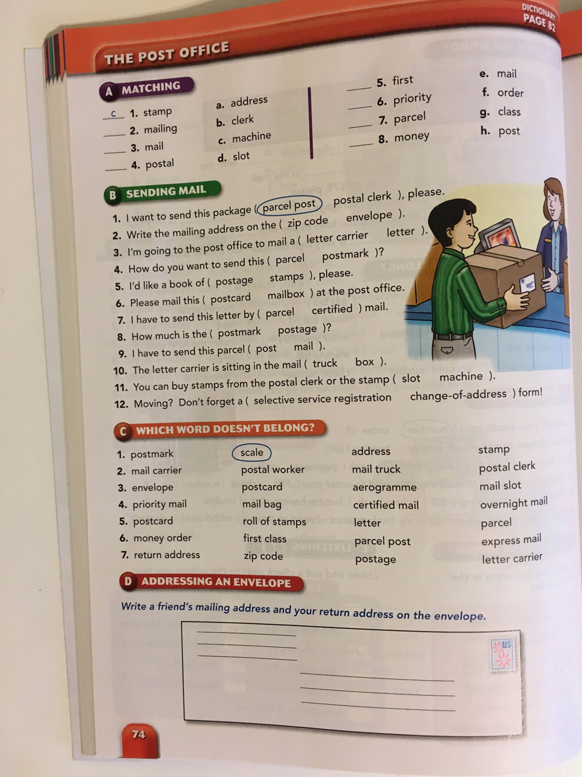
Appendix G
Word by Word Picture Dictionary Table of Contents
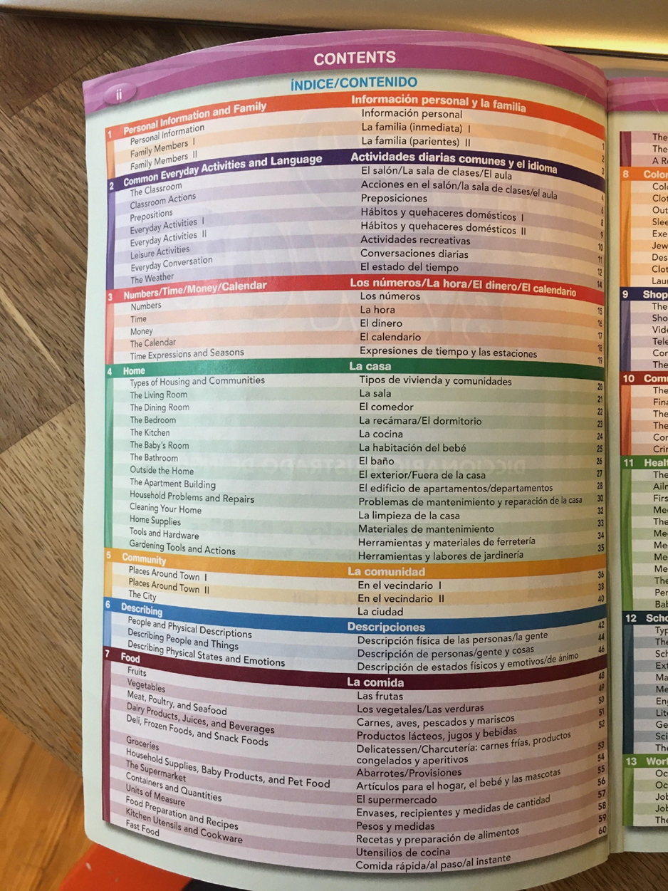
Word by Word Picture Dictionary Table of Contents, continued
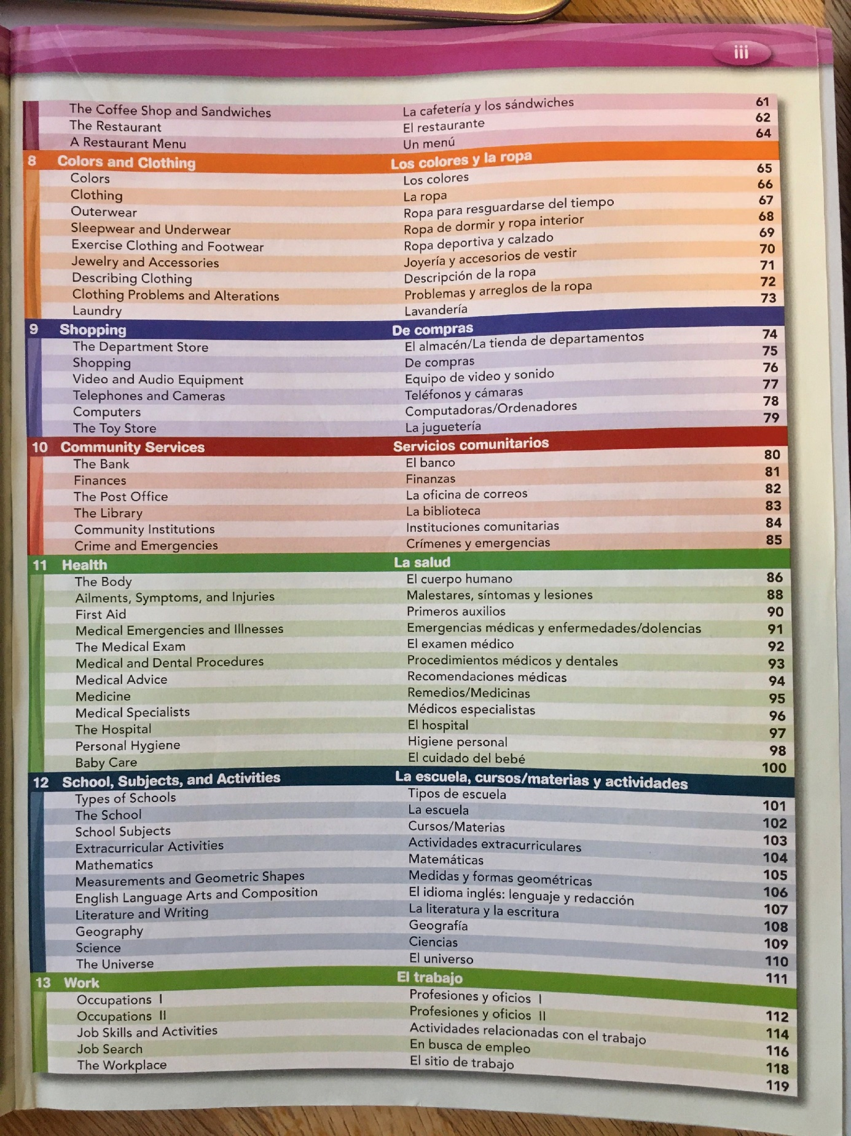
Appendix H
Word by Word Picture Dictionary description of communication skills (sample)
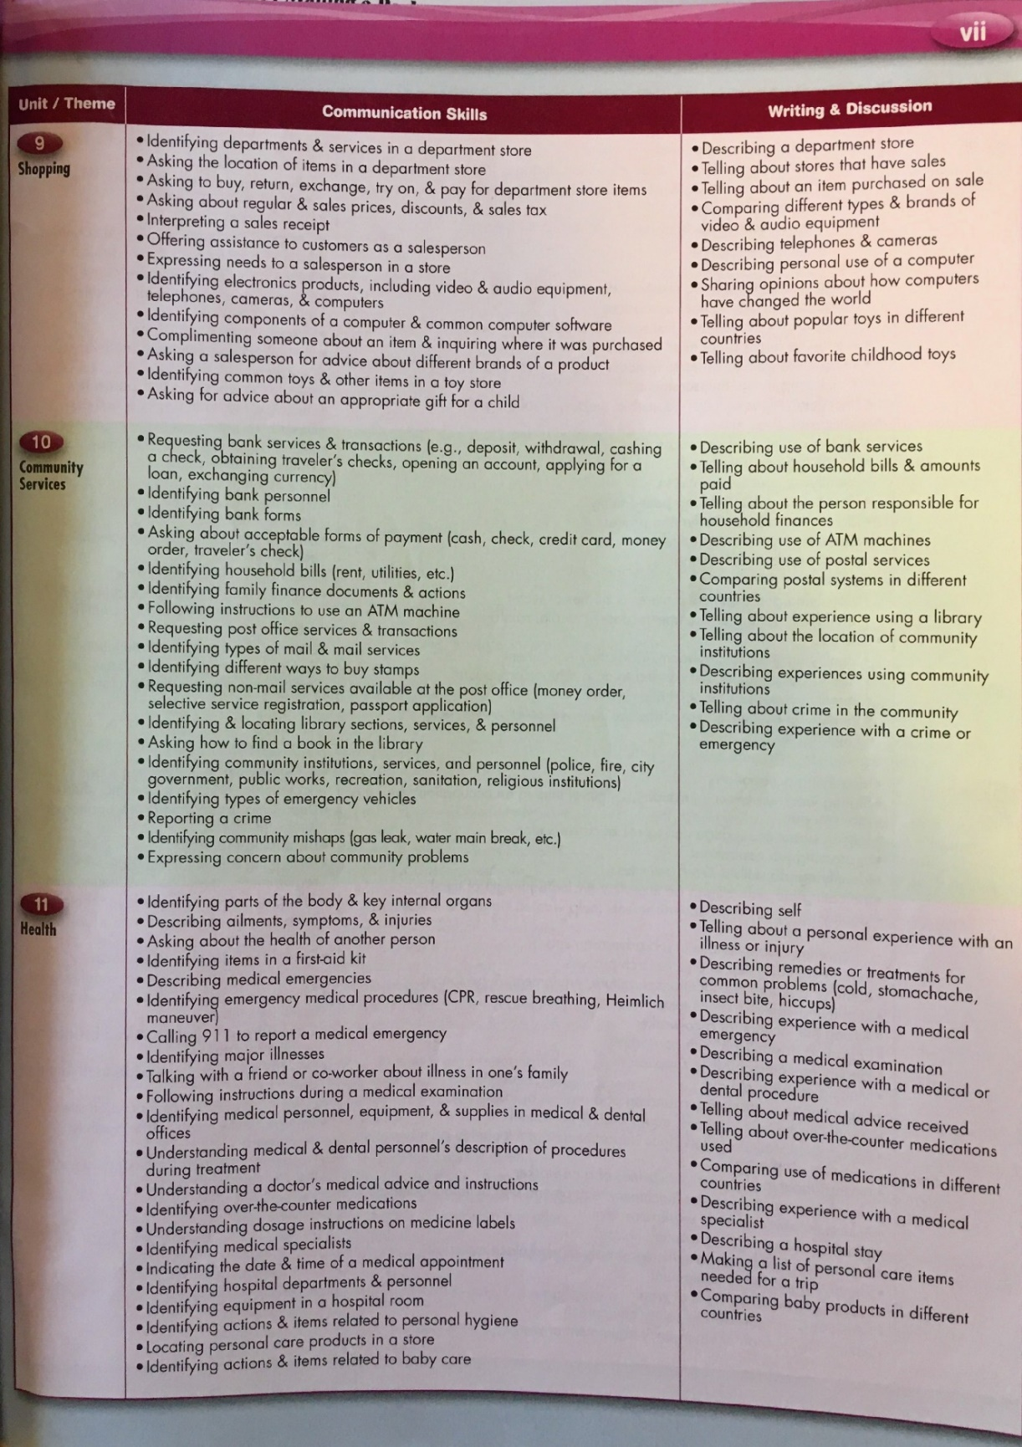
Appendix I
Post Office Vocabulary Quiz (closed book, multiple choice)
Click here to access Google Forms quiz

Appendix J
Teaching Video Instructions
(Instructions will be translated to Spanish for students.)
- Choose 3 vocabulary words from this week’s section of the Word by Word Picture Dictionary. Choose words that you didn’t know or use before and that you think would be useful to you in your daily life.
- Make a video on VoiceThread to teach your classmates the three vocabulary words you chose. For this video, you are the teacher!
- In the video, you need to:
  - Say the word (use an online dictionary or Google Translate app to check your pronunciation, first!)
  - Repeat the word two more times.
  - Give the meaning of the word in Spanish.
  - Give an example sentence using the word.
  - Use a memory device (picture, rhyme, action, or song) to help people remember it (you can use Spanish for this part).
  - Repeat steps for the other two words.

Appendix K
Vocabulary Review Instructions
(Instructions will be translated to Spanish for students.)
You will be assigned one of the situations we learned about during this class (post office, restaurant, grocery store, etc.) Follow the instructions below to make a vocabulary review video on VoiceThread.
- Look over the section in the Word by Word Picture Dictionary and your note cards or notebook.
- Watch the video lesson from that week.
- Choose 1 phrase and 5 individual words that you think are important to remember.
- Create a video using the words you chose. Repeat each word and phrase two or more times in your video. Check your pronunciation to make sure it is correct! In your video, explain how you could use these words and phrase in a situation in real life (you can do this part in Spanish).

Appendix L
Video Report Instructions
(Instructions will be translated to Spanish for students.)
After you complete the task for the week, create a video on VoiceThread to talk about what you did. In your video you need to answer these questions:
- Where did you go? (name of place and town) “I went to ______”
- What day did you complete the task? “I went on ______”
- How did you feel right before starting your task? (This part can be in Spanish)
- What did you say? (Say exactly what you said in English)
- How did the person you were talking to respond? (Try to tell as much as you remember in English)
- How did you feel after you finished your task? (This part can be in Spanish)
It is very important that you include ALL this information in your video. You might want to write down these points on an index card to make sure you don’t forget anything when you are making your video.

Appendix M
Exit Interview Questions
(Interviews will be conducted in Spanish.)
- Why did you want to take this class?
- What was the biggest way this class helped you?
- What was something about this class that was different than you expected?
- Did the length of this class feel too short, too long, or just right?
- Was this class harder, easier, or about as difficult as you expected?
- What is one part of the class that was difficult or challenging for you?
- What is one thing you would change about the class to make it better?
- Has the way you feel when you’re speaking English changed since you started this class? In what way?
- What do you want to do now and in the future to continue improving your English?
- What kind of English classes would you like to take in the future?

